Northwick Park Academy Trust


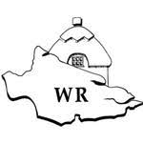
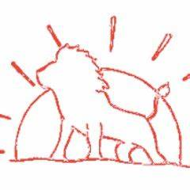

Calculation Policy for Mathematics

Purpose of our Calculation Policy
This policy has been written in accordance with the National Curriculum. It is designed to provide pupils with a consistent and fluent progression of learning when using the four main operations.
The calculation policy is organised according to age related expectations as set out in the National Curriculum; however it is vital that pupils are taught according to the stage that they are currently working at, moving on when they are secure. Decisions about when to progress should always be based on the security of the pupils’ understanding. Pupils who grasp concepts rapidly should be challenged through being offered rich and sophisticated problems before any acceleration through new content.
It is important to note that ability to calculate mentally is a skill that goes hand in hand with these more formal written methods. Whilst this policy focuses on written methods of calculation in mathematics, we recognise the importance of the mental strategies and know that these, alongside known facts form the basis of all calculations.
We understand that pupils need to experience a range of resources and have different representations shown to them to enable them to understand concepts and build on their own experiences when moving onto written recordings for calculations. This policy will explain and identify the links between concrete, pictorial and abstract methods and links with the school’s long term maths plan and progression document.

Concrete | Using manipulatives and practical resources to model, visualise and practically demonstrate the mathematical concepts. The resources may be specifically designed classroom manipulatives such a Base 10, place value counters or Numicon, or in other situations may be relative manipulatives to support the problem in hand, for example apples, sweets or teddy bears. Concrete manipulatives help to reinforce and support understanding of calculation methods and should be used across the school.
Pictorial | Visual representations of manipulatives or numbers to support mathematical understanding. This is a crucial stage as it helps children make the vital cognitive links between practical and abstract written methods by drawing or looking at pictures or diagrams to help understand the concepts involved in a calculation. This should be used across the school.
Abstract | Once a child demonstrates a solid understanding of the concrete and pictorial representation of a method, they should move on to explaining their understanding through abstract symbols and calculation methods.

Addition: Reception
Addition Key Concept | Concrete | Pictorial | Abstract
Find 1 more than a number to 10 | 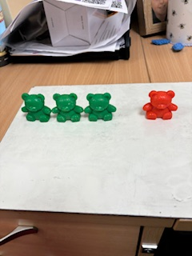  Use practical apparatus  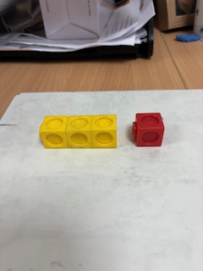 | 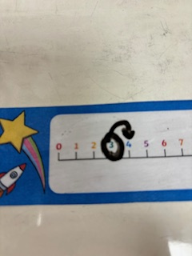  Use a number line | Instant recall of 1 more  What is 1 more than 3? 4
Combine two groups to make a total | Use practical apparatus and add the two groups together by counting them all  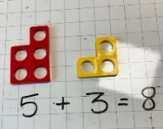  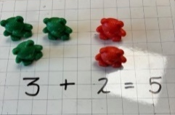 | 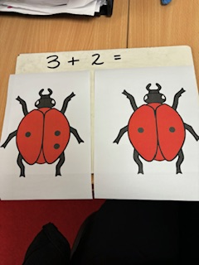  Use pictures and add the two groups by counting them all
Counting on (starting at the biggest number) | 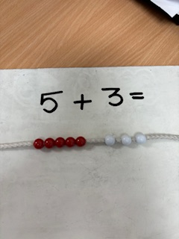  They may not be ready for this until Year 1  Start with the biggest number and count on – use manipulatives | They may not be ready for this until Year 1  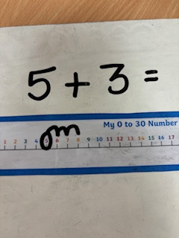  Use a number line – starting at the bigger number and drawing on the jumps
Recall number bonds up to 5 (and some number bonds to 10) | 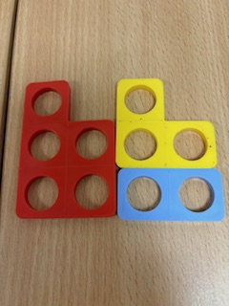  Use Numicon, bead strings, tens frames to explore number facts to 5 and then 10  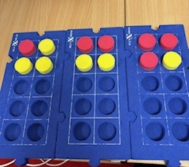 | 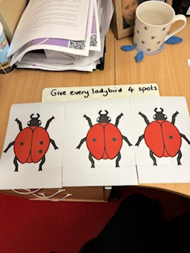  Use pictorial models | Recall number bonds to 5 (and then to 10)  3 and 2 makes 5  4 and 1 makes 5  5 and 0 makes 5  What do I add to 2 to make 4? 2  What do I add to 1 to make 4? 3

Addition: Year 1
Addition Key Concept | Concrete | Pictorial | Abstract
Combining two groups to find a total | Use practical apparatus  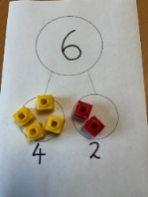  Use a part-part-whole  model | 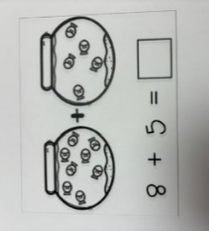  Use pictures to add two numbers together | Use the part-part-whole model  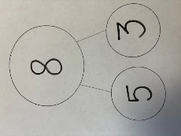  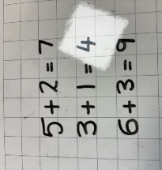  Solve simple  addition statements
Counting on (starting at the bigger number) | Use fingers for addition within 10 use – start with the biggest number and count on  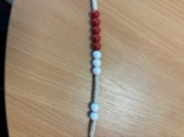  Use a bead string – start at the bigger number and count on a bead at a time 1 by 1 to find the answer | Use a number line – starting at the bigger number and drawing on the jumps  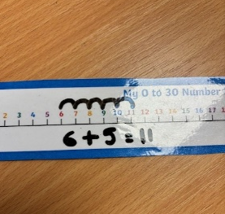 | Place the larger number in your head and count on the smaller number to find the answer  12 + 5 = 13,14, 15,16,17
Memorise and reason with number bonds to 10 and 20 | Use Numicon, bead strings, tens frames and part-part-whole models to explore number facts to 10 and then 20  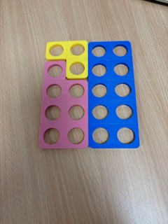  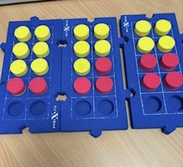  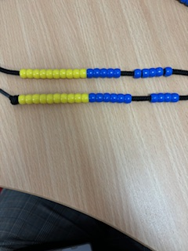 | 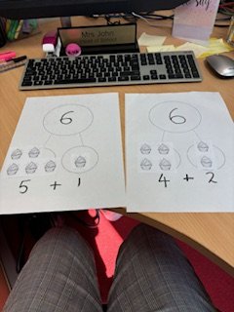  Use pictorial part-part-whole models | Use written statements and appropriate linked addition and subtraction symbols  1+19 = 20  2+18 = 20  3 + 17 = 20  6 + 1 = 7  1 + 6 = 7  7 – 1 = 6  7 – 6 = 1
Regrouping to make 10 | 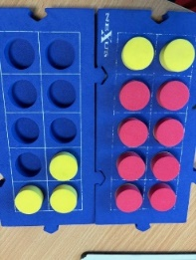  Use bead strings or ten frames – start with the bigger number and use the smaller number to total 10 then identify how many more are needed  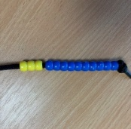  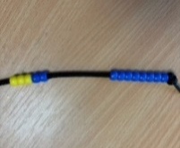 | Use pictures or a number line  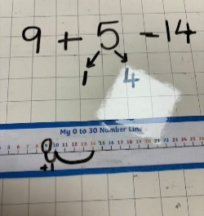  Regroup or partition a smaller number to make 10 | How many more do I need to make 10? How many do I have left to add on?  7 + 4  7 + 3 more makes 10  Add the 1 more left from the 4 which takes me to 11

Addition: Year 2
NB Children will need to be confident with partitioning 2-digit numbers into tens and ones before using some of these methods.
Addition Key Concept | Concrete | Pictorial | Abstract
Counting on (starting at the bigger number) | Use a number line to add on a 1-digit number  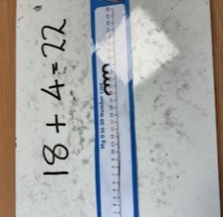 | Draw a blank number line to add on ones  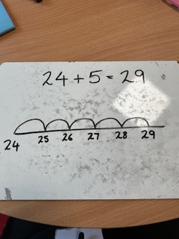 | Place the larger number in your head and count on the smaller number to find the answer  38 + 5 = 39,40,41,42,43
Memorise and reason with number facts to 20 | 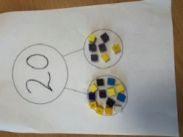  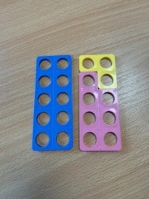  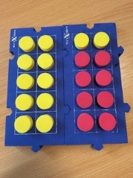  Use Numicon, tens frames and part-part-whole models to explore number facts to 20 | 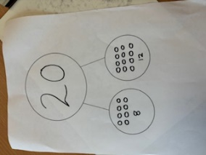  Use pictorial part-part-whole models | Use written statements and appropriate linked addition and subtraction symbols  14 + = 20  20 - = 14
Adding three single-digit numbers | 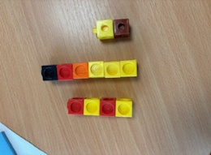  Use Numicon, tens frame, cubes or a number line  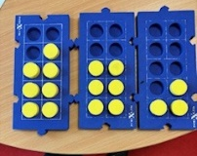  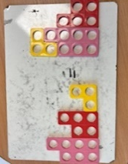 | Use a blank number line or part-part-whole models to draw out each number  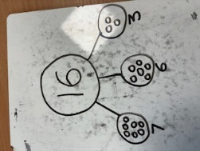  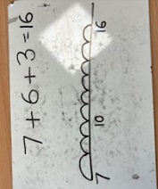 | Combine two numbers that make or bridge ten, then add on the third  7 + 6 + 3 = 16  7 + 3 = 10  10 + 6 = 16
Adding multiples of 10 | 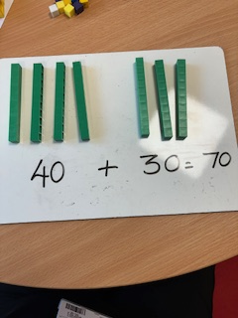  Use base 10 apparatus to aid with counting up in groups of ten | 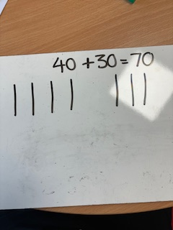  Draw base 10 representations | Use written statements and vocabulary of tens  20 + 30 = 50  70 = 50 + 20  40 + = 60
Add a two-digit number and tens | Explore how the ones digit does not change using base 10  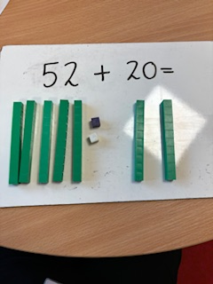 | 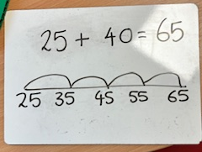  Use a number line to count on in tens | Count on in tens mentally to answer questions  34 + 30 = 44, 54, 64  Solve missing digit problems  34 + 10 =44  34 + =54  34 + =64
Adding pairs of two-digit numbers | 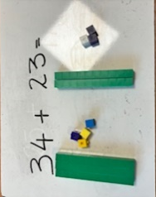  Use base 10 apparatus (initially without crossing the tens boundary and then including regrouping)  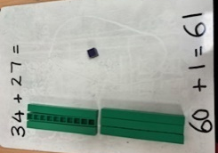  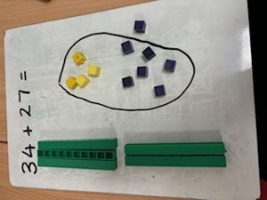 | Use a pictorial method (hot cross bun method) initially without crossing the tens boundary and then including regrouping)  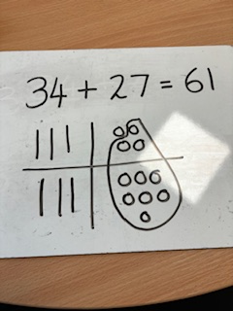  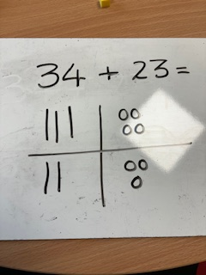 | Expanded addition (initially without crossing the tens boundary and then including regrouping)  34 + 23 = 57  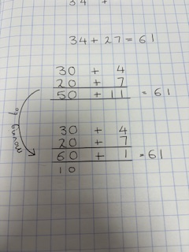  30 + 4  20 + 3  50 + 7

Addition: Year 3
Addition Key Concept | Concrete | Pictorial | Abstract
Addition of two-digit and three-digit numbers  (numbers which do not bridge 10) | Partition numbers and represent with base 10 apparatus or place value counters  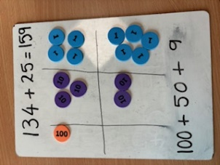  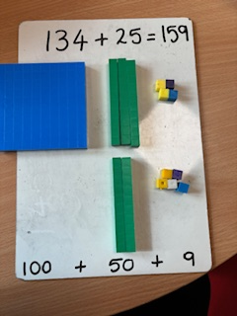 | Draw the counters or the base 10  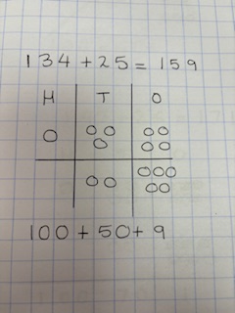  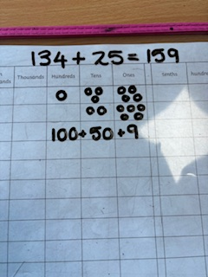 | Expanded addition moving to a compact method of column addition  134 + 25 = 159  100 + 30 + 4  20 + 5  100 + 50 + 9  134  + 25  159
Addition of two-digit and three-digit numbers with regrouping | Use base 10 or place value counters to exchange  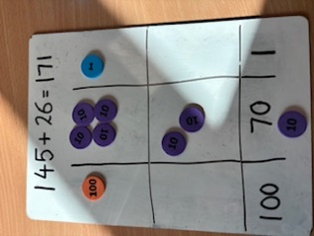  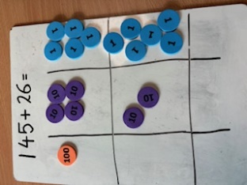 | 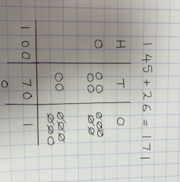  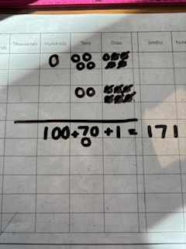  Draw a representation of the practcial apparatus (model carrying under the line) | 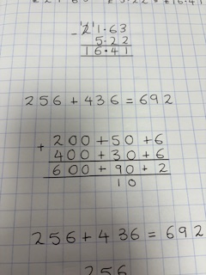  Expanded addition moving to a compact method of column addition  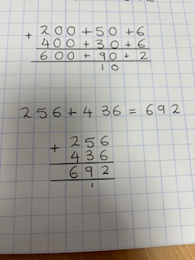

Addition: Year 4
Addition Key Concept | Concrete | Pictorial | Abstract
Add pairs of numbers with up to 4 digits | Continue to use base 10 apparatus or place value counters to aid with addition and bridging between columns  See Year 3 | Draw representations using place value grids  See Year 3 | Use column addition
Add money using decimal notation | Use base 10 or place value counters to aid with bridging between columns  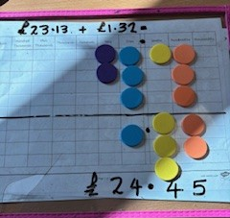  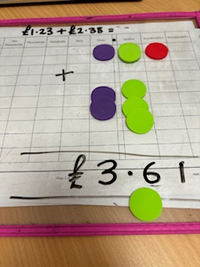  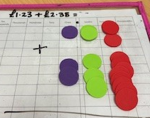 | Use a place value grid to aid understanding of lining up digits  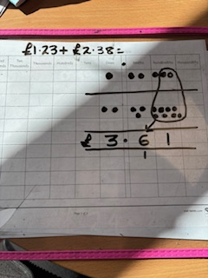 | Column addition method, bridging  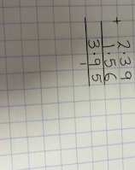  between columns
Addition: Year 5 and Year 6
Column method with regrouping | Consolidate understanding using numbers with more than 4 digits and extend by adding numbers with up to 3 decimal places including in the context of money and measures

Subtraction: Reception
Subtraction Key Concept | Concrete | Pictorial | Abstract
Find 1 less than a number to 10 | 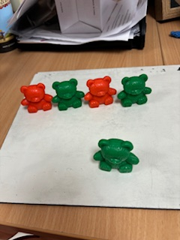  Use practical apparatus and remove one | 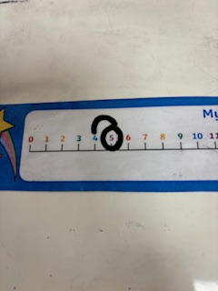  Use a number line and jump back one | Instant recall of 1 less  What is 1 less than 5? 4
Take away from a set | 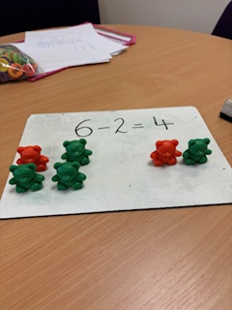  Use practical apparatus and remove from the set and count to find the new total | 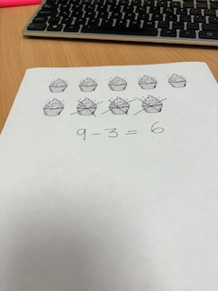  Cross out pictures to show which have been taken away
Counting back in ones | They may not be ready for this until Year 1  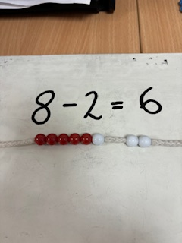  Use a bead string – start at the bigger number and count back one bead at a time to find the answer | They may not be ready for this until Year 1  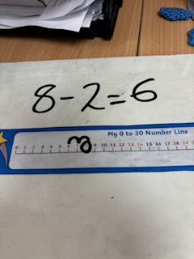  Use a number line – start at the biggest number and jump backwards in steps of 1
Recall subtraction  facts to 5 | Use tens frames or objects to explore subtraction facts to 5  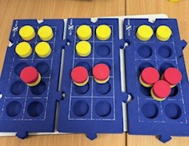 | 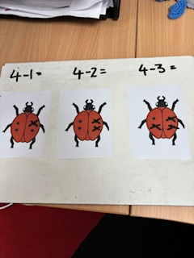  Use pictorial models and representations | Recall subtractions facts to 5  5 – 1 = 4  4 – 1 = 3 4 – 2= 2 4 – 3 = 1  5 – 2 = 3

Subtraction: Year 1
Subtraction Key Concept | Concrete | Pictorial | Abstract
Understand subtraction as take away  Take away ones | Use physical objects to take away ones from a number within 10 and then 20 | Cross out pictures to show which have been taken away | Solve simple number sentences  7 – 1 = 6  7 - 2 = 5  7 – 3 = 4  7 – 4 = 3
Counting back in ones | 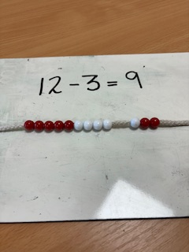  Use a bead string – start at the bigger number and count back one bead at a time to find the answer | 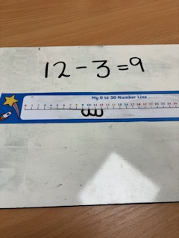  Use a number line – jump backwards in steps of 1 | Place the larger number in your head and count back  11 - 4 = 10, 9, 8, 7
Memorise and reason with number facts to 10 and then 20 and explore related subtraction facts | Use tens frames and part-part-whole models  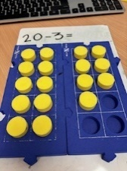  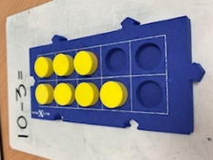  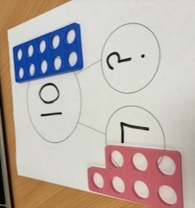 | Use pictorial representations to show part-part-whole models  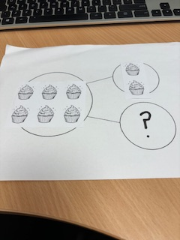  Use a number line and part-part-whole model  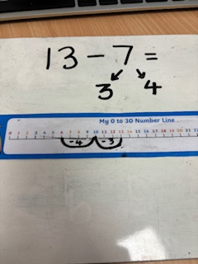  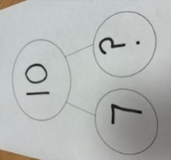 | Recall subtraction facts linked to knowledge of addition  4 + 6 = 10  10 – 6 = 4  3 + 4 = 7  7 – 4 = 3

Subtraction: Year 2
NB Children will need to understand partitioning and how to regroup a ten into tens ones
Subtraction Key Concept | Concrete | Pictorial | Abstract
Counting back | Jump back using a bead string  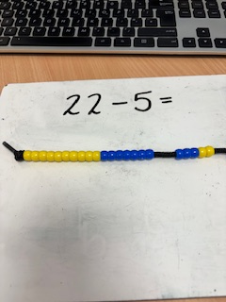  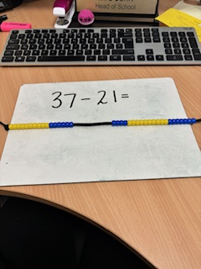 | 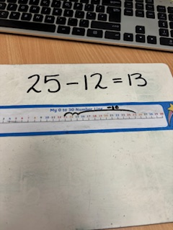  Jump back on a number line  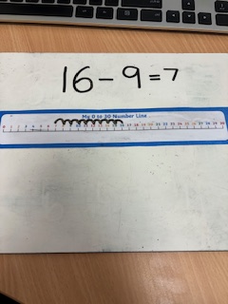  Draw a blank number line to jump back  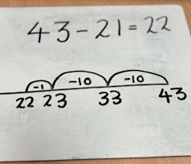 | Place the larger number in your head and count backwards in steps of ones or tens and then ones  35 - 7 = 34,33,32,31,30,29,28  58 - 22 = 48,38, 37,36  or  58 – 22 =  58 – 20 = 38  38 – 2 = 36
Subtract tens from a two-digit number | Explore how the ones digit does not change using base 10 or numicon  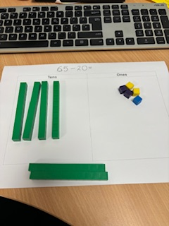 | 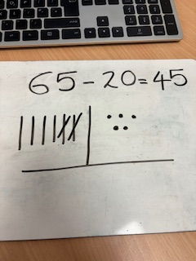  Draw base 10 representations (half a hot cross bun) or a blank number line to count back in tens  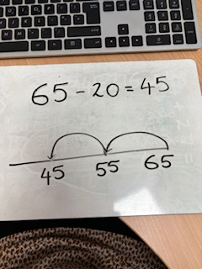 | Count back in tens mentally to answer questions  74 - 30 = 64, 54, 44  Solve missing digit problems  64 - 10 =54  64 - =44  64 - =34
Subtracting a two-digit number from a two-digit number  (without the need for regrouping) | Use base 10 apparatus  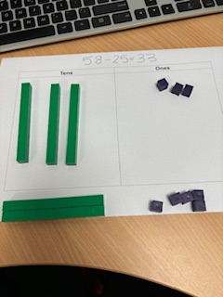 | 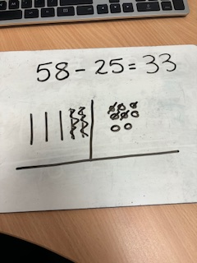  Use a pictorial method (half hot cross bun method) | Expanded column subtraction  (may not be introduced until Year 3)  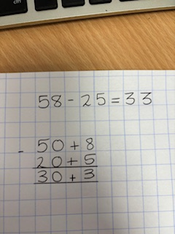
Subtracting a two-digit number from a two-digit number (where regrouping is needed) | 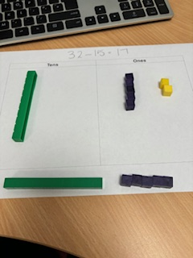  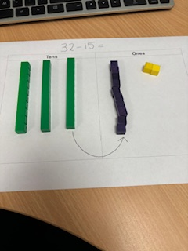  Use base 10 apparatus | 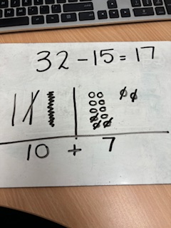  Use a pictorial method (half hot cross bun) | Expanded column subtraction  (may not be introduced until Year 3)  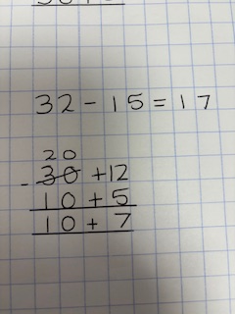

Subtraction: Year 3
Subtraction Key Concept | Concrete | Pictorial | Abstract
Subtraction of up to three digits using columns (without regrouping) | Use base 10 apparatus or place value counters and physically remove hundreds, tens and ones  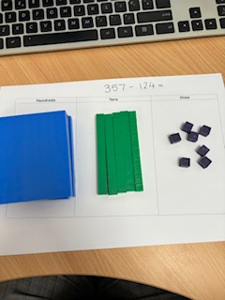 | Support understanding through visual representations  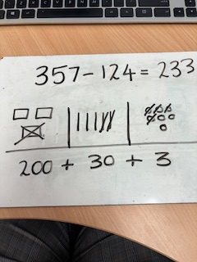 | 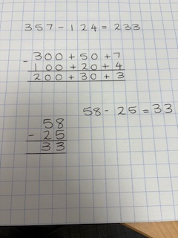  Column subtraction – expanded method used first and then move to a compact method  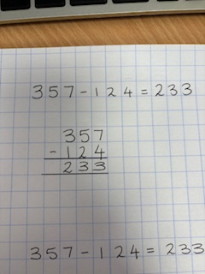  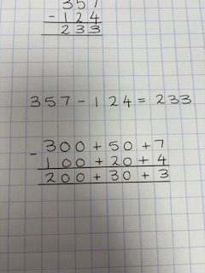
Subtraction of up to three digits using columns (with regrouping) | Use base 10 or place value counters to exchange and subtract  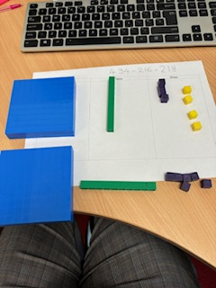  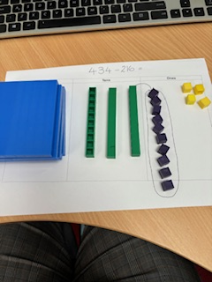 | 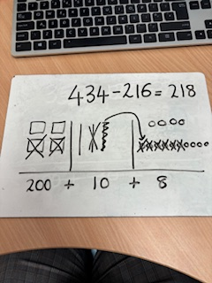  Use visual representations and crossings out to exchange and subtract | 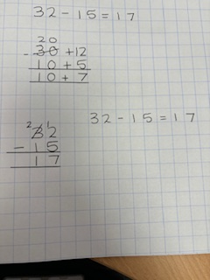  Column subtraction – expanded method used first and then move to a compact method  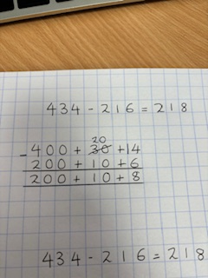  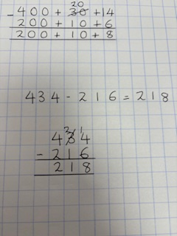

Subtraction: Year 4
Subtraction Key Concept | Concrete | Pictorial | Abstract
Subtraction with up to four digits | Continue to use base 10 apparatus or place value counters to subtract and exchange  See Year 3 | Use visual representations and crossings out to exchange and subtract  See Year 3 | 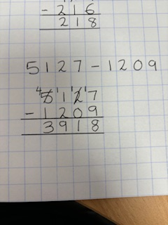  Use column subtraction, exchanging between columns
Subtract money using decimal notation | 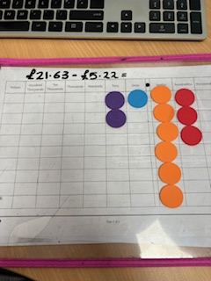  Use base 10 or place value counters to exchange  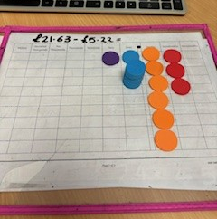  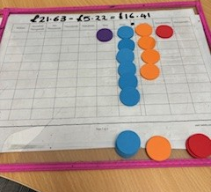 | Use a place value grid to aid understanding of lining up digits  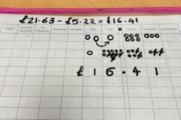 | Column subtraction method, exchanging  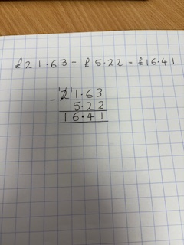  between columns
Subtraction: Year 5 and Year 6
Column method with regrouping | Consolidate understanding using numbers with more than 4 digits and extend by subtracting numbers with up to 3 decimal places including in the context of money and measures

Multiplication: Reception
Multiplication Key Concept | Concrete | Pictorial | Abstract
Double numbers to 5 | Real life contexts and practical activities using manipulatives like cubes or Numicon  Pupils are encouraged to find doubles by creating two groups of the same size  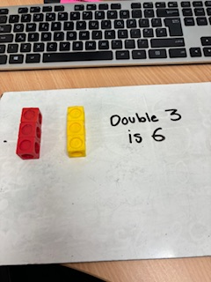  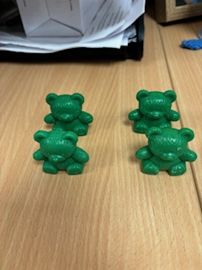  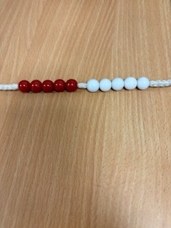 | 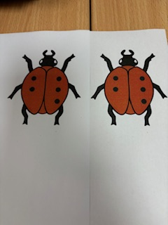  Use pictorial representations to find doubles | Recall double facts  Double 2 is 4  Double 5 is 10

Multiplication: Year 1
Multiplication Key Concept | Concrete | Pictorial | Abstract
Doubling single digit numbers | Practical activities using manipulatives like cubes or Numicon  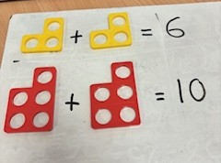 | 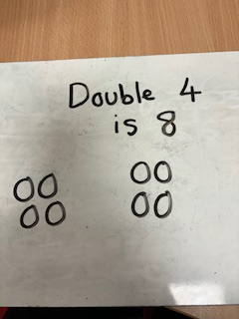  Draw pictures to demonstrate doubling | Answer questions  Double 5 is 10  Double 3 is 6
Count up in multiples | Use beads strings, multi-link cubes, Numicon to count in multiples  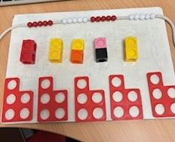 | 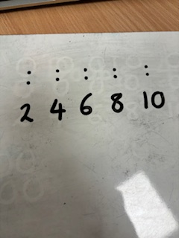  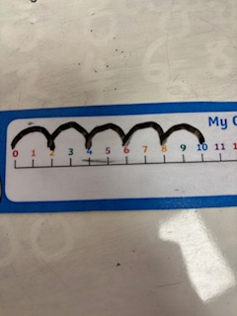  Make representations or use jumps on a number line to show counting in multiples | Count aloud or write multiple sequences  2,4,6,8,20  5,10,15,20,25,30
Make equal groups and count the total | 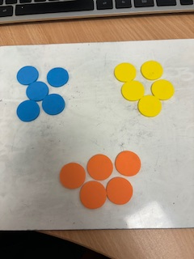  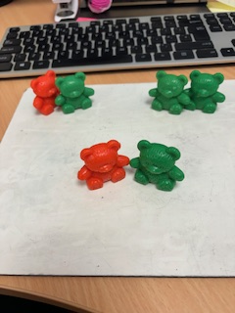  Use counters, cubes or other manipulatives to make equal groups and add together | 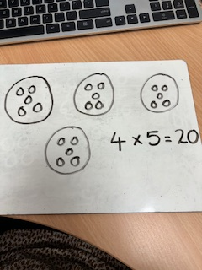  Draw different representations to show equal groups and totals | Write a number sentence and answer it  3 x 2 = 6  2 x 5 =10
Understand multiplication as repeated addition | 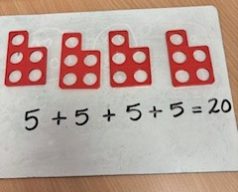  Use different manipulatives and objects to make and add equal groups using repeated additon | 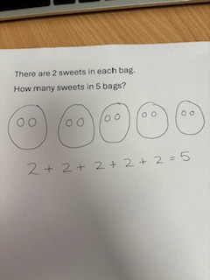  Use pictures to solve problem using repeated addition (link to the multiplication number sentence) | Solve repeated addition number sentences. Start to recognise the multiplication number sentence which matches a repeated addition  5 + 5 + 5 = 15  3 x 5 = 15
Represent multiplication number sentences using arrays | They may not be ready for this until Year 2  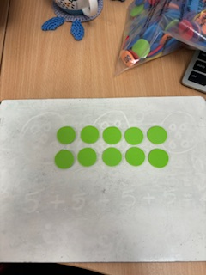  Lay counters, cubes or other manipulatives out in arrays to visualise multiplication | They may not be ready for this until Year 2  Draw representations of arrays to demonstrate understanding of multiplication facts  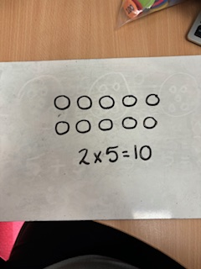

Multiplication: Year 2
Multiplication Key Concept | Concrete | Pictorial | Abstract
Double two-digit numbers | Use base 1 apparatus, place value counters or Numicon to partition and then double  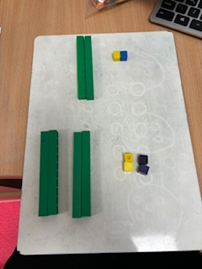 | 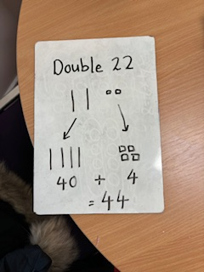  Draw representations to demonstrate partitioning and recombining | Partition a number, double each part and then use addition to recombine  Double 14  10 doubled 20  4 doubled 8  20 + 8 = 28
Counting in multiples | 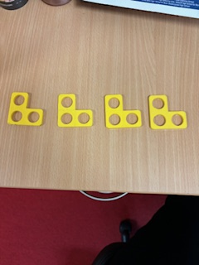  Use beads strings, Numicon, counters or cubes to make groups and then count in multiples  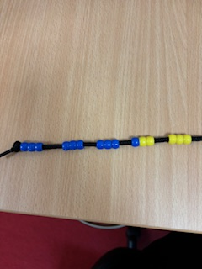 | 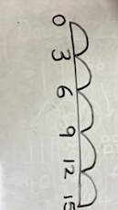  Make representations or use jumps on a number line to show counting in multiples | Count aloud or write multiple sequences  3,6,9,12,15  5 x 3 = 15
Further develop understand of multiplication as repeated addition | 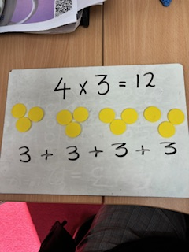  Recognise from a multiplication statement how many equal groups are needed, make with manipulatives and add to find the total | 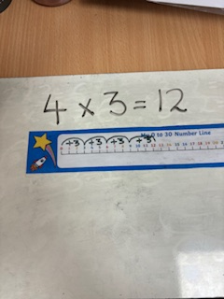  Bridge the link from repeated addition to solve multiplication problems using a number line | Recognise repeated addition number sentences and write as a multiplication number sentence  3 + 3 + 3 + 3 = 12  4 x 3 = 12
Use arrays to solve simple multiplication calculation. | 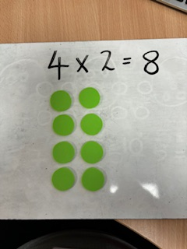  Lay counters, cubes or other manipulatives out in arrays to answer questions | 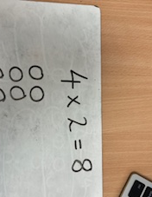  Draw representations of arrays to demonstrate understanding of multiplication facts | Answer multiplication number sentences  4 x 3 = 12  2 x 5 = 10
Understand the commutative law of multiplication | 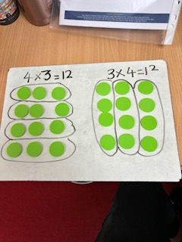  Lay counters, cubes or other manipulatives out in arrays and understand that these groups can be interpreted both horizontally and vertically without the answer changing | 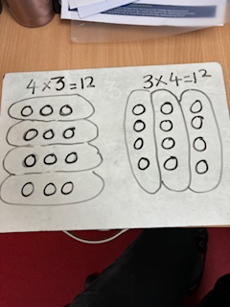  Draw arrays and group horizontally and vertically to explore the rule of commutativity | Write multiplication sentences in different orders to show the answers are the same  4 x 3 = 12  3 x 4 = 12
Begin to develop understanding of inverse | 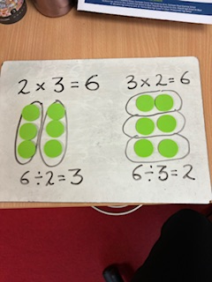  Begin to identify the link between multiplication and division through deconstruction of arrays into groups | 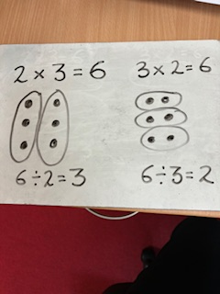  Draw arrays to answer multiplictaion statements and then identify groups within the arrays to solve division | Write related fact family number sentences  2 x 3 = 6  3 x 2 = 6  6 ÷ 2 = 3  6 ÷ 3 = 2

Multiplication: Year 3
Multiplication Key Concept | Concrete | Pictorial | Abstract
Consolidate understanding of arrays and the commutative law of multiplication  Make links to division as the inverse | Use counters and set out in arrays and understand that these groups can be interpreted both horizontally and vertically without the answer changing  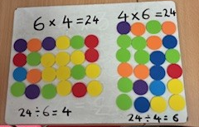 | Draw arrays and group horizontally and vertically to explore the rule of commutativity  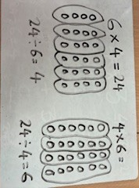 | Write related fact family number sentences  6 x 4 = 24  4 x 6 = 24  24 ÷ 6 = 4  24 ÷ 4 = 6
Multiply a two-digit number by a one-digit number using grid method | 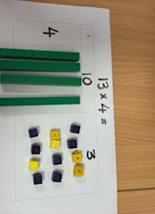  Partition the two-digit number and use base 10 or place value counters to represent each total and then add together  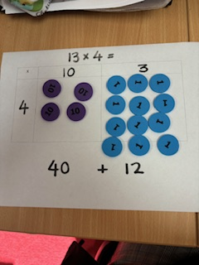 | 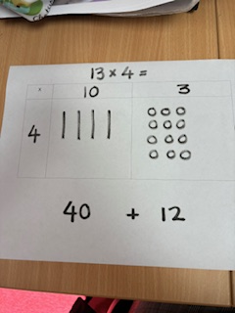  Represent place value counters or base 10 in a grid | 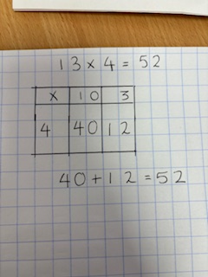  Solve multiplication calculations using the grid method with only numbers

Multiplication: Year 4
Multiplication Key Concept | Concrete |  | Pictorial | Abstract
Multiply a two-digit or three-digit number by a single digit using grid method | 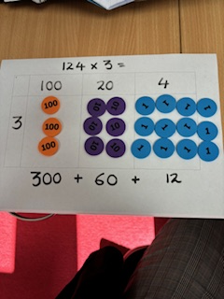  Partition the two-digit or three-digit number and use base 10 or place value counters to represent each total and then add together  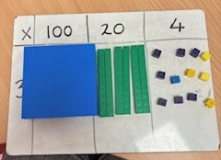 |  | Represent totals with images of place value counters or base 10 in a grid  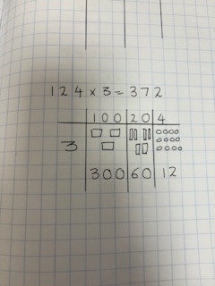 | Solve multiplication calculations using the grid method with only numbers  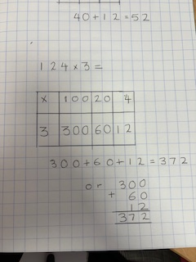
Multiply a two-digit or three-digit numbr by a single digit using a written method. | 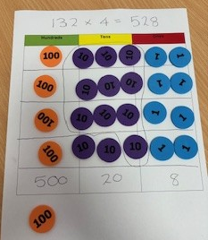  Use place value counters (either physically or drawn representations) to understand the link between columns and bridging through addition. Introduce the explanded vertical method alongside.  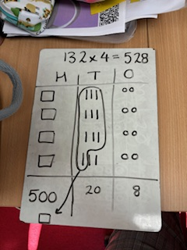  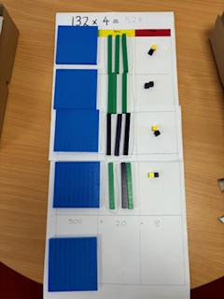  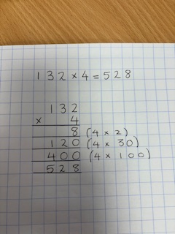 |  |  | 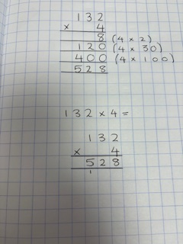  Use a compact method for multiplication
Multiplication: Year 5
Multiplication Key Concept | Concrete |  | Pictorial | Abstract
Multiply a whole number by a single digit using a written method | See Year 4 - extend to more than 3 digits |  | See Year 4 - extend to more than 3 digits | 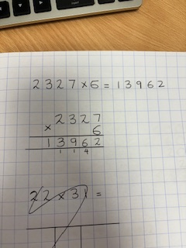  Use a compact method for multiplication
Multiply a two-digit number by a two-digit number (with no or little bridging involved) | Use base 10 or place value counters to visualise the size of larger numbers using the grid method and partitioning (keep to simple numbers to avoid bridging and concentrate on familiarity)  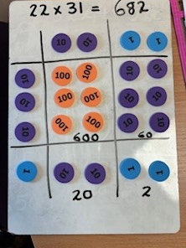 | 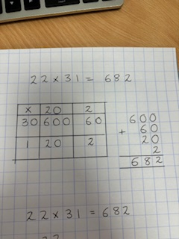  Use the grid method to see each part when multiplying and draw the place value counters if necessary (keep to simple numbers to avoid bridging and concentrate on familiarity) |  | 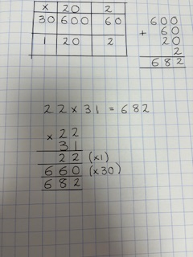  Use the long multiplication method identifying each step (keep to simple numbers to avoid bridging and concentrate on familiarity)
Multiply a two-digit or three-digit number by a two-digit number | 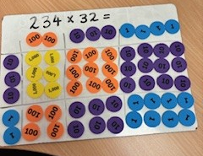  Use place value counters to visualise the size of larger numbers using the grid method | 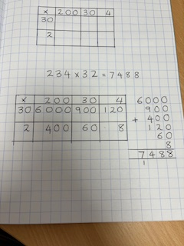  Use the grid method to see each part when multiplying |  | 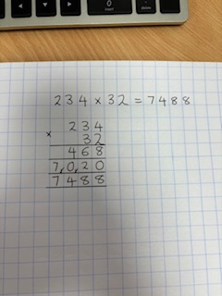  Use the long multiplication method

Multiplication: Year 6
Multiplication Key Concept | Concrete |  | Pictorial | Abstract
Multiply a whole number by a two-digit number | See Year 5 | See Year 5 |  | 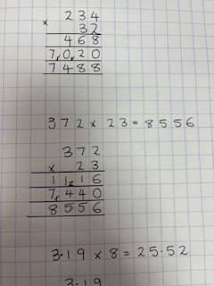  Use the long multiplication method
Multiply a decimal number by a one-digit number |  |  |  | Use the short method of multiplication. Remind pupils that the number that you are multiplying by needs to be lined up with the ones digit  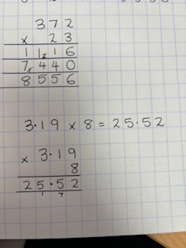  As with all decimal work the decimal points must be lined up vertically

Division: Reception
Division Key Concept | Concrete | Pictorial | Abstract
Sharing into equal groups | By the end of Reception, we expect pupils to understand how to share out items in play and problem solving into equal groups.  Activities might include:  - sharing of sweets on child’s birthday  - sharing activities in the home corner
Finding half | Finding half of objects and numbers by sharing into two equal groups  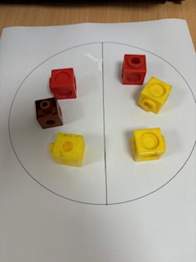  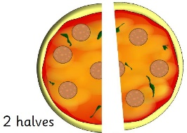
Division: Year 1
Division Key Concept | Concrete | Pictorial | Abstract
Understand division as sharing by solving one step problems by sharing into equal groups | Physically share amounts in equal groups using manipulatives  Use large practical resources like balls in hoops or children onto mats  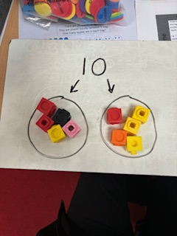 | 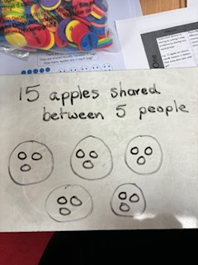  Draw representations of sharing | Simple worded statements (the division sign can be shared with the children)  15 apples shared between 5 people means 3 apples each

Division: Year 2
Division Key Concept | Concrete | Pictorial | Abstract
Consolidate understanding of division as sharing | See Year 1 | See Year 1 | See Year 1
Understanding division as grouping by counting in multiples and identifying the number of groups needed | Divide quantities into equal groups  Use concrete representations such as Numicon to show the link between division and multiplication or organise groups into arrays to demonstrate the link  Use resources and manipulatives to group practically  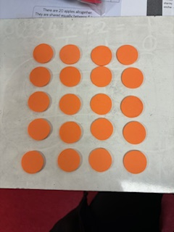  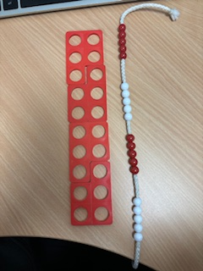 | 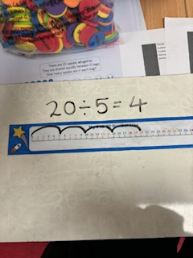  Use visual representations including arrays and number lines to identify groups  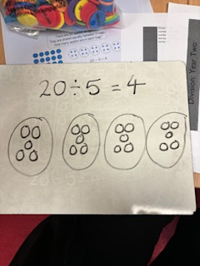  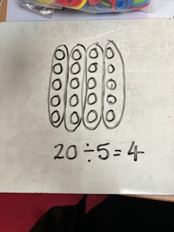 | Use the division symbol to record division calculations and count in multiples to find the answer  20 ÷ 5 = 4  5, 10, 15, 20
Divide two-digit numbers by a one-digit number (equal sharing with no exchange) | 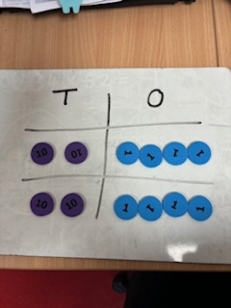  Use base 10 or place value counters and partition the two-digit number into tens and ones  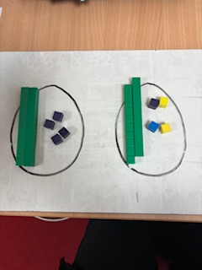 | Draw visual representations using the  part-whole model  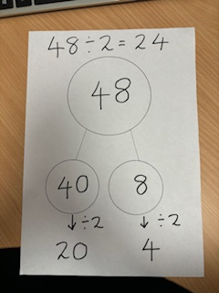 | Write number statements to show division  48 ÷ 2 = 24

Division: Year 3
Division Key Concept | Concrete | Pictorial | Abstract
Division with arrays | 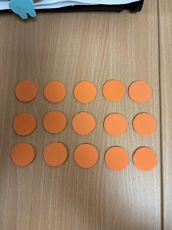  Link division to multiplication by creating practical arrays and turning these into number sentences | Draw pictorial arrays and split into groups in order to identify number sente  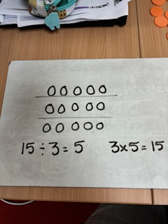  nces  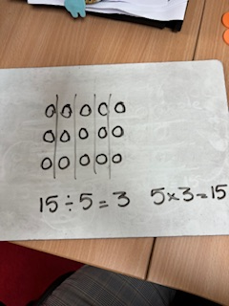 | Write number sentences linking division and multiplication  3 x 5 = 15  5 x 3 = 15  15 ÷ 3 = 5  15 ÷ 5 = 3  Model that the answer can be on either side of the equal sign  15 = 3 x 5  15 = 5 x 3  3 = 15 ÷ 5  5 = 15 ÷ 3
Divide two-digit numbers by a one-digit number by grouping (no exchange) | Use base 10 or place value counters and partition the two-digit number into tens and ones  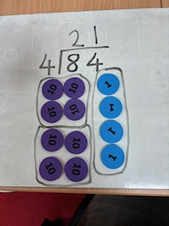 | Draw visual representations using base 10 or place value counters  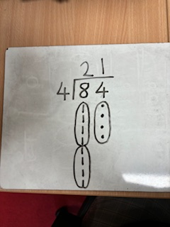 | 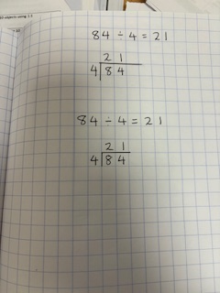  Begin to use the short division method (bus stop)
Divide a two-digit number by a one-digit number where exchanging is needed | They may not be ready for this until Year 4  Use manipulatives such a base 10 or place value counters to exchange one ten for ones where needed  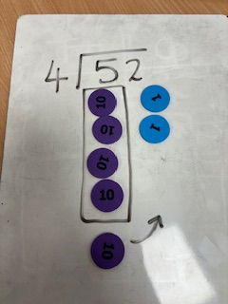  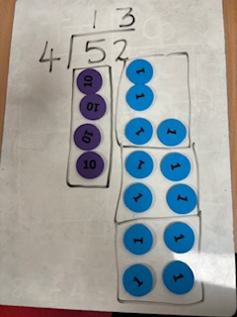 | They may not be ready for this until Year 4  Draw visual representations of base 10 or place value counters  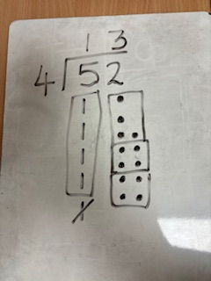 | They may not be ready for this until Year 4  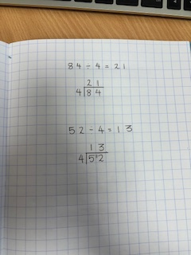  Begin to use short division (bus stop)

Division: Year 4
Division Key Concept | Concrete |  | Pictorial | Abstract
Consolidate dividing a two-digit number by a one-digit number where exchanging needed  Extend to dividing a three-digit number by a one-digit number | Use manipulatives such a base 10 or place value counters to exchange one ten for ones where needed  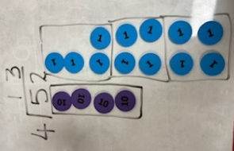  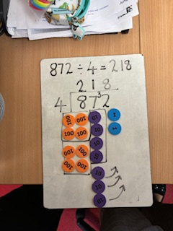 | Draw visual representations of base 10 or place value counters  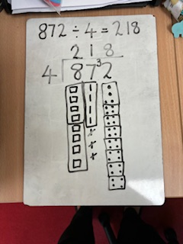 |  | 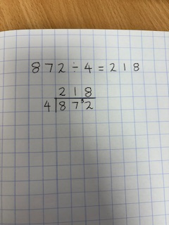  Use short division (bus stop)
Division with remainders  (use small numbers initially) | 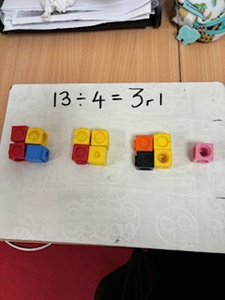  Practically divide objects into equal groups and identify what is left over | Use a number line to identify how many equal groups can be made and how many are left over  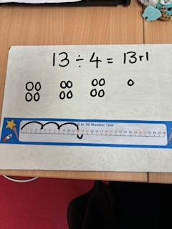  Use pictures to group the amount and see how many are left over |  | Complete written division calculations and use ‘r’ to show the remainder  13 ÷ 4 = 3 remainder 1  13 ÷ 4 = 3 r1

Division: Year 5
Division Key Concept | Concrete |  | Pictorial | Abstract
Consolidate division of up to 4 digits including answers with remainders | Use manipulatives such a base 10 or place value counters and exchange where needed  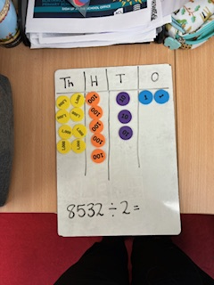  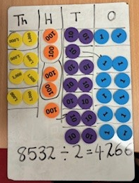 |  | Draw visual representations of base 10 or place value counters  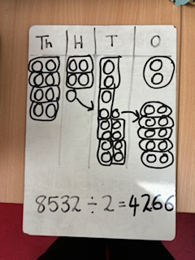 | 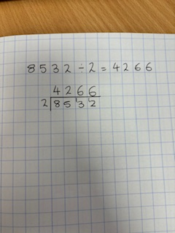  Use short division (bus stop)
Interpreting remainders |  | Understand how the context of calculations will change what the remainder represents  78 apples are placed in bags of 9. How many apples are left over?  78 ÷ 9 = 8 r 6  8 bags with 6 apples left over  Limousines seat 8 people. How many will need to be hired for a group of 67 people?  67 ÷ 8 = 8 r 3  8 limousines would not be enough so an extra one would be needed for the 3 remaining people, therefore 9 limousines must be hired.

Division: Year 6
Division Key Concept | Concrete |  | Pictorial | Abstract
Expressing the remainder as a fraction (according to the context) |  |  |  | 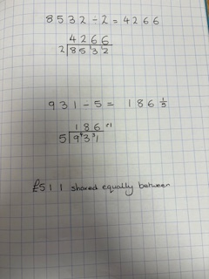  Instead of having a remainder show the answer as a fraction
Expressing the remainder as a decimal (according to the context) |  |  |  | Instead of having a remainder, put in a decimal point and placeholder zeros  Ensure a decimal point is put in the same position in the answer  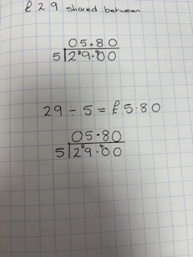  £29 shared equally between 5 people
Dividing by a two-digit number |  |  |  | 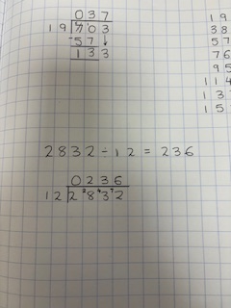  Children should be taught that short division can be used effectively when dividing by a low teen number  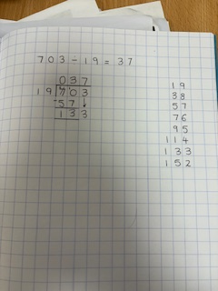  Children will use long division to divide numbers with up to four digits by a two-digit number

