Wellbeing Update

July 2022 Northwick Park Primary & Nursery Academy
Mental Health Champions
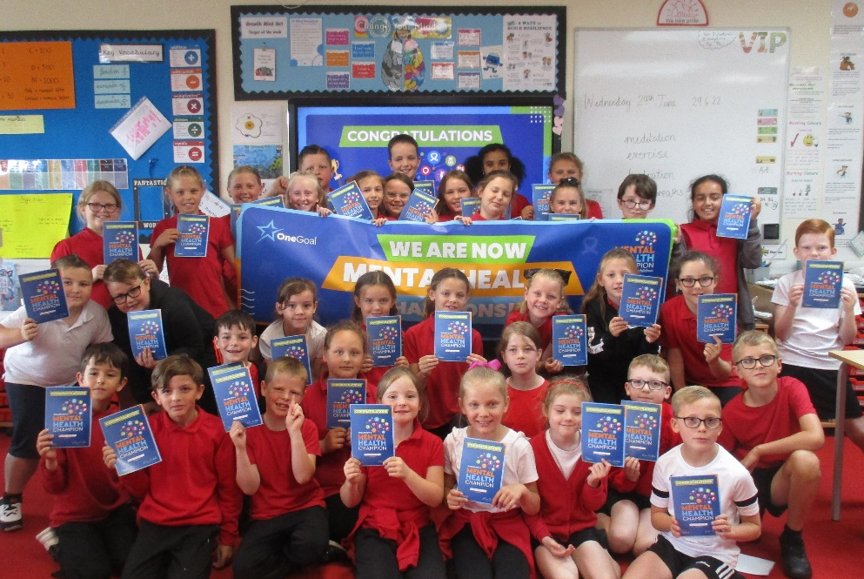
On Wednesday 29th June, a selection of successful applicants from years 3, 4 and 5, who had applied for the role, participated in an active Mental Health Champion workshop. The training was delivered by an external company, One Goal. The children enjoyed an active workshop which allowed them to learn and practise a range of strategies that can be followed in order to maintain positive mental health. The children participated in a range of practical tasks that were designed to develop the skills required to be a Mental Health Champion. The children enjoyed the session and were pleased to receive a certificate during the graduation ceremony. From September, these children will be our Mental Health Champions. They will receive additional training next year to ensure they feel confident in supporting their peers on the playground.

Year 3 | Year 4 | Year 5
Joey  Josie  Lara  Esme  Blue  Tilly  Jack  Alfie  George  Eleanor  Parker | Michael  Florie  Poppy-Leigh  Isla-Arose  Isabella  Zach  Rubie  George  Tilly  Teddy | Shelby  Jacob  Scarlett  Baylee  Ola  Ellie-Rose  Holly  Bobbie  Iris  Tillie  Brooke  Kaiden  Amelia  Sabrina  Isabella
HAVE YOUR SAY

As a school, we have continued to review and implement many strategies to support our staff members, children and parents with their wellbeing. If you have any further ideas or suggestions to help us improve the wellbeing of our children, please share these by using the suggestion box which can be found in our entrance area.
End of Year Highlights
Each year group have reflected on their wellbeing activities from the year and decided on their favourite task.
Year 1 enjoy returning from lunch to watch a calming mindfulness video.
Reception enjoyed their session with Bonnie who shared a meditation story.

Year 2 loved creating their support balloons which allowed them to think about the people that support them as they grow.
Year 3 always look forward to completing their ‘Peace out’ relaxation every day after lunch.
Year 5 thoroughly enjoyed making their beautiful glitter jars during wellbeing week.
Year 6 enjoy completing mindfulness colouring and guided meditation to music.
Year 4’s highlight was when they were visited by Bonnie who practiced colour breathing with them.

